[***https://developer.twitter.com/en/docs/twitter-api/v1/data-dictionary/overview***](https://developer.twitter.com/en/docs/twitter-api/v1/data-dictionary/overview)

**Standard Version (Standard Format - Native Format)**

“At Twitter we serve many objects as JSON, including *Tweets and* *Users*. These objects all encapsulate core attributes that describe the object. Each Tweet has an author, a message, a unique ID, a timestamp of when it was posted, and sometimes geo metadata shared by the user. Each User has a Twitter name, an ID, a number of followers, and most often an account bio.

With each Tweet we also generate "entity" objects, which are arrays of common Tweet contents such as hashtags, mentions, media, and links. If there are links, the JSON payload can also provide metadata such as the fully unwound URL and the webpage’s title and description.”

Example:

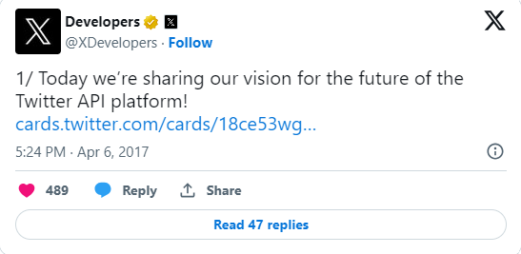

{ "created_at": "Thu Apr 06 15:24:15 +0000 2017",

"id_str": "850006245121695744",

"text": "1\/ Today we\u2019re sharing our vision for the future of the Twitter API platform!\nhttps:\/\/t.co\/XweGngmxlP",

"user": {

"id": 2244994945,

"name": "Twitter Dev",

"screen_name": "TwitterDev",

"location": "Internet",

"url": "https:\/\/dev.twitter.com\/",

"description": "Your official source for Twitter Platform news, updates & events. Need technical help? Visit https:\/\/twittercommunity.com\/ \u2328\ufe0f #TapIntoTwitter"

},

"place": {

},

"entities": {  
 "hashtags": [

],

"urls": [

{

"url": "https:\/\/t.co\/XweGngmxlP",

"unwound": {

"url": "https:\/\/cards.twitter.com\/cards\/18ce53wgo4h\/3xo1c",

"title": "Building the Future of the Twitter API Platform" } } ],

"user_mentions": [

] } }

### **Standard v1.1 vs v2 payload structure**

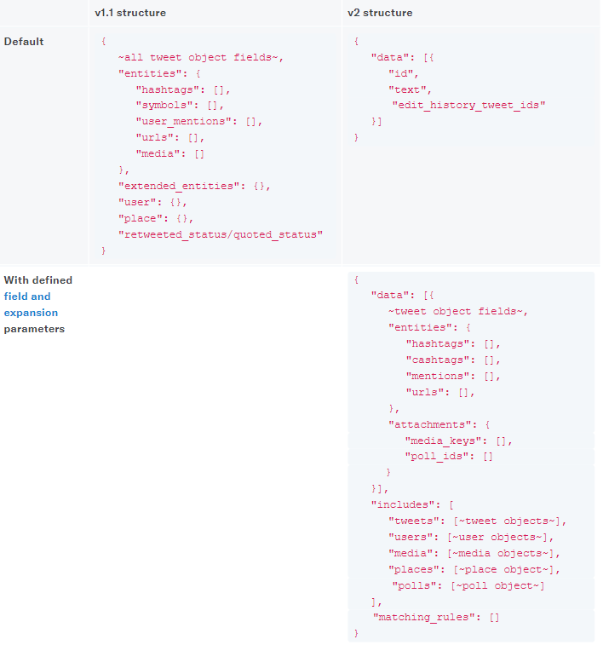

***https://developer.twitter.com/en/docs/twitter-api/migrate/data-formats/standard-v1-1-to-v2***